**Setting Environment:**



**All Databases:**

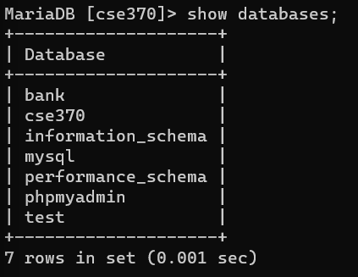

**Using Bank Database:**



**All Tables in Bank database:**

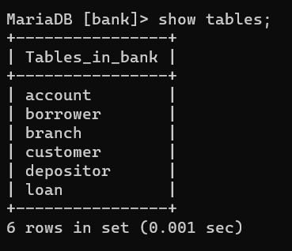

**Tables After Inserting Data:**

Account:

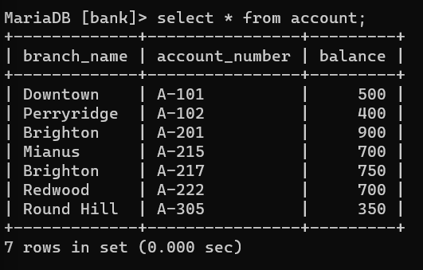

Borrower:

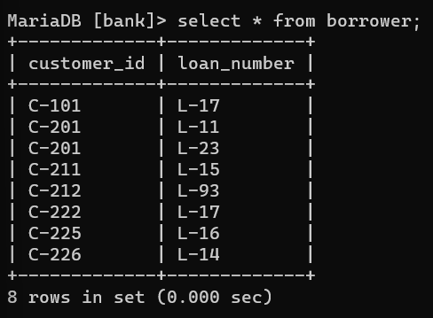

Branch:

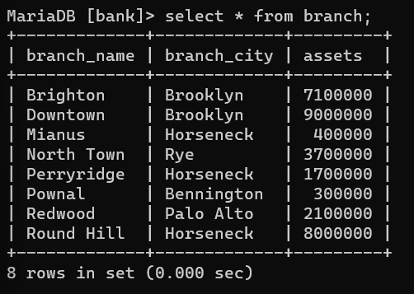

Customer:

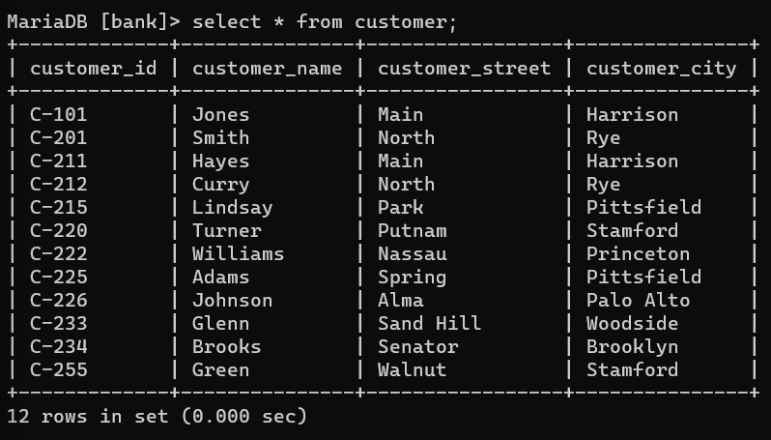

Depositor:

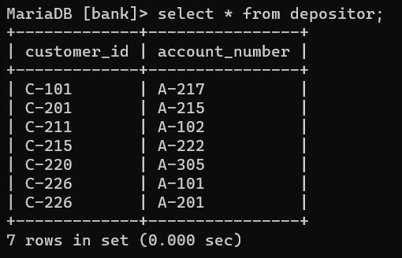

Loan:

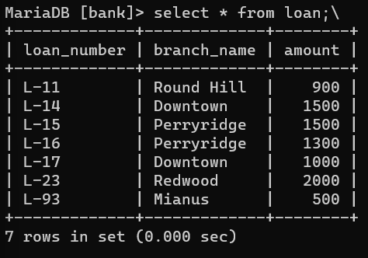

**TASK 1:** SELECT c.customer_name, l.loan_number

-> FROM ((customer c INNER JOIN borrower b ON c.customer_id=b.customer_id) INNER JOIN loan l ON b.loan_number=l.loan_number)

-> WHERE l.branch_name="Downtown";

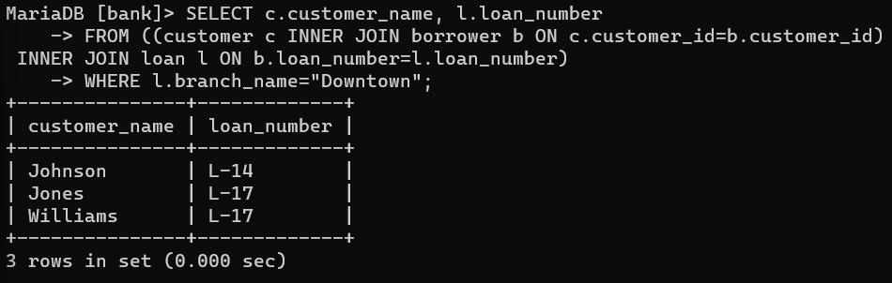

**TASK 2:** SELECT c1.customer_name AS Customer1, c2.customer_name AS Customer2, c1.customer_city as City

-> FROM (customer c1 INNER JOIN customer c2 ON c1.customer_id < c2.customer_id AND c1.customer_city = c2.customer_city);

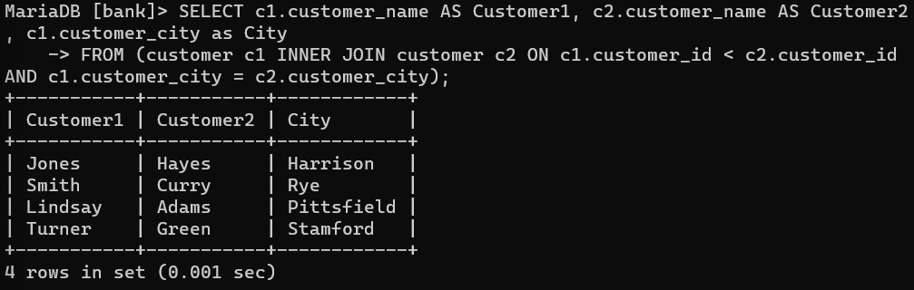

**TASK 3:**  SELECT a.branch_name AS Branch_name, SUM(a.balance * 0.04) AS Total_Interest

-> FROM account a

-> GROUP BY a.branch_name;

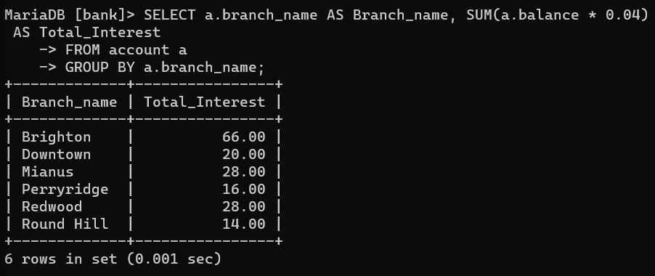

**TASK 4:** SELECT c.customer_city AS City, a.account_number AS Account_Number, a.balance AS Highest_Balance

-> FROM (customer c INNER JOIN account a ON c.customer_id = a.branch_name)

-> WHERE (c.customer_city, a.balance) IN

-> (SELECT c.customer_city, MAX(a.balance)

-> FROM (customer c INNER JOIN account a ON c.customer_id = a.branch_name))

-> GROUP BY c.customer_city;

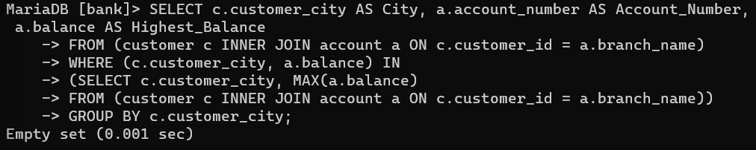

**TASK 5:** SELECT l.loan_number, l.amount, c.customer_name

-> FROM ((loan l INNER JOIN borrower b ON l.loan_number = b.loan_number)

-> INNER JOIN customer c ON b.customer_id = c.customer_id)

-> ORDER BY l.amount DESC, l.loan_number ASC

-> LIMIT 5;

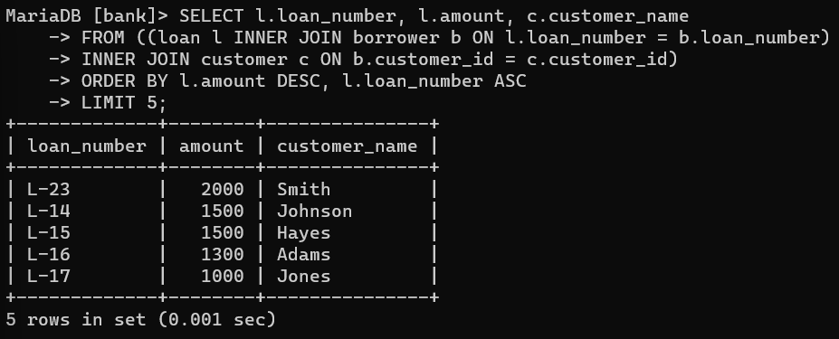

**TASK 6:** SELECT DISTINCT c.customer_name

-> FROM ((((customer c INNER JOIN depositor d ON c.customer_id = d.customer_id)

-> INNER JOIN account a ON d.account_number = a.account_number)

-> INNER JOIN borrower b ON c.customer_id = b.customer_id)

-> INNER JOIN loan l ON b.loan_number = l.loan_number)

-> WHERE a.branch_name = 'Perryridge' AND l.branch_name = 'Perryridge';

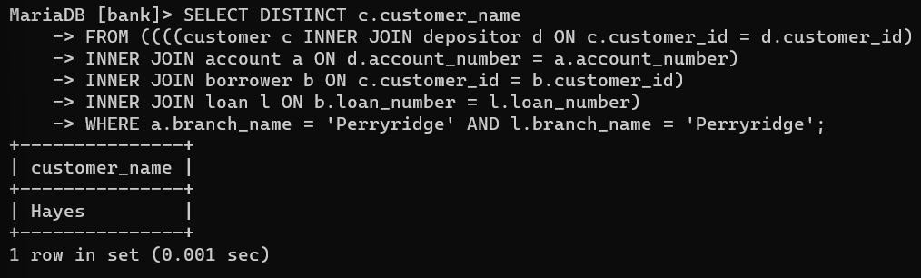

**TASK 7:** SELECT c.customer_name, SUM(l.amount) AS total_loan

-> FROM ((customer c INNER JOIN borrower b ON c.customer_id = b.customer_id)

-> INNER JOIN loan l ON b.loan_number = l.loan_number)

-> GROUP BY c.customer_id

-> HAVING COUNT(b.loan_number) >=2;

